What is the problem?
I have 8 ¼” tread depth for each tread for the stairs from the 1st to 2nd floor and the stairs from the 2nd floor to 3rd floor attic. I need 9”
The house is 95%, complete, so to fix this problem, it would almost require starting the project over. The existing stairwell would need to be one foot longer, which would cause major framing/structural changes.

From 7th ed 780 CMR,
copied from page 11 of 22 via link http://www.mass.gov/Eeops/docs/dps/780 CMR/780053c.pdf
5311.5.3.2 Tread Depth. The minimum tread depth shall be nine inches (229 mm). The tread depth shall be measured horizontally between the vertical planes of the foremost projection of adjacent treads and at a right angle to the tread’s leading edge.
Because of the limitations of the stairwell framing, I cannot cut new stringers in the existing stairwell to fix the tread depth without making the rise greater than 8 ¼”, which is not allowed per the following
5311.5.3.1 Riser Height. The maximum riser height shall be 8¼ inches (210 mm). The riser shall be measured vertically between leading edges of the adjacent treads. The greatest riser height within any flight of stairs shall not exceed the smallest by more than d inch (9.5\mm).

If I keep the riser height < 8 ¼” and make the tread depth 9”, this makes the stair stringers longer by about a foot. If I do that, then I will fail the head clearance requirements on the first stepx.
5311.5.2 Headroom. The minimum headroom in all parts of the stairway shall not be less than six feet six inches (1981 mm) measured vertically from the sloped plane adjoining the tread nosing or from the floor surface of the landing or platform.

So what is the project, and at what stage of completion is it?

Starting in June 2009, this ranch
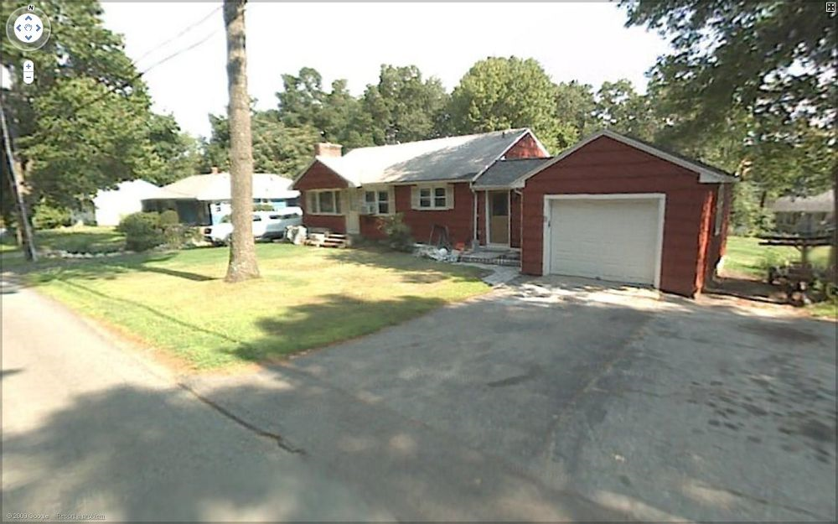
was turned into this 3 story colonial
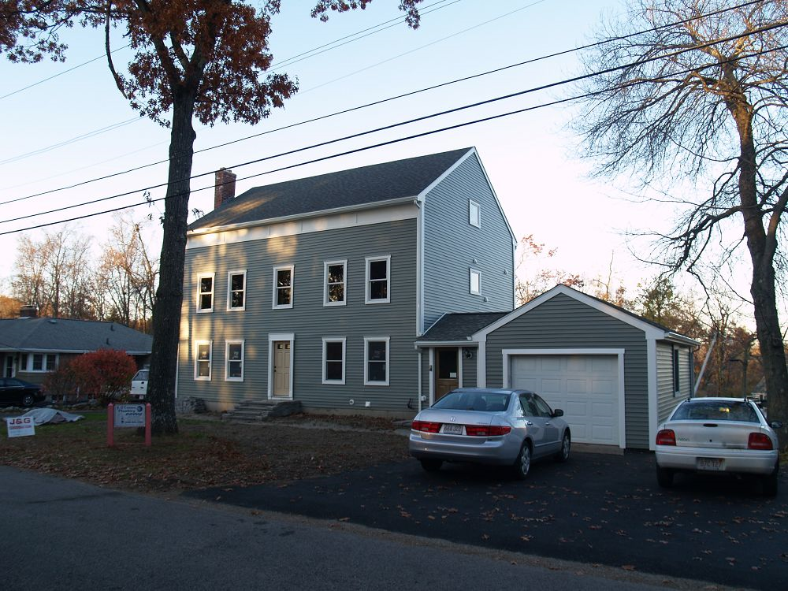
On the current permit, I have passed the following in the listed order:
Rough framing, Rough plumbing, Rough electrical, Insulation, Final plumbing, Final Electrical, and Final smoke detection system (by the fire dept)
Only the final inspection has failed due to a stairway tread depth problem (8 ¼ vs min 9”). Currently, the house is completely plastered and painted inside. Interior doors have been installed. I still need to install hardwood flooring on the 2nd floor, finish the stairs, and install trimwork everywhere (baseboard, door, window…)

Why are the tread depths 8 ¼”?
The stringers were cut with a run of 8 ¼” and a rise of 7 7/8”. In the diagram below, I’m trying to show that even though the treads are 9.5” deep, they overhang the backerboards by 1 ¼”, so you have subtract that in determining the tread depth per the building code.
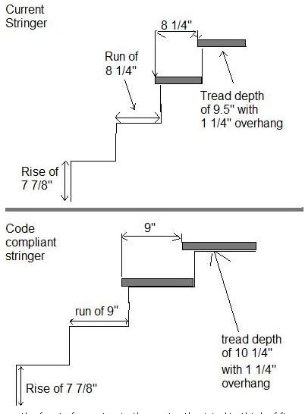

To fix the problem I would need new stair stringers cut like below, but this makes the stringers longer.
Here’s the main problem though in cutting new stringers.
The corrected stringers for the 1st to 2nd floor would be 9 ¾” longer (= 13 steps * ¾”).
The corrected stringers for the 2nd to 3rd floor would be 12” longer (= 16 steps * ¾”).

If new stringers are made, I would also have to change the stairwell framing to accommodate them, this would be extremely difficult.

How did this happen?

I (Dan Hunneyman, owner, acting general contractor of the project) didn’t read the building code about stairs at the time of rough framing, I only checked recently to make sure my finished treads would be ok. Obviously, I should have checked the code much earlier.

It looks like the architect plans approved by the building department had an error. See next page.

Neither the builder or his carpenter that cut the stringers realized the stringer runs should be at least 9” deep. Personally, I remember them being mostly concerned about the rise height and head room clearance.

The building inspector didn’t find the problem during the rough framing inspection. The stringers were cut from LVL beams and installed with 2x10 treads at the time of the rough framing inspection, but in fairness, there was a lot to check given the scope of the project. I remember having to fix some structural issues (adding blocking to continue load down to the foundation in a few places), so that could be why it was missed.

Finally, the house is a difficult design to remodel because the stairs are not in line with the floor joist direction. The stairs run from the chimney side of the house to the garage side, but the joists run from the front of the house (street view) to the back. This makes the structural issues more difficult to change because the stairs run perpendicular to the joists. The following pages help explain that issue I hope.

Please note: In all the following drawings, the scales listed are not correct because these cad drawings were not resized via the appropriate software for this paper size. However the relative proportions in the drawing are correct.

What happens if I have to change the stairwell framing?
In this architect drawing below, (part of the submitted plans to the Shrewsbury Building Dept), you can see the stacked stairs are the same width. But, the existing basement stairs had an existing grandfathered (from 1957) tread depth of 8 ¼”, and they also only have a head clearance of 66” on the 2nd to last step, 1 ft shorter than code (I’m 6’3”, so I’ve learned to duck). Therefore, the top two stairs should be much wider in the picture below to show the extra space they need. To fix this, I would have to start in the basement by adding more lally columns at the bottom left of the stairs. 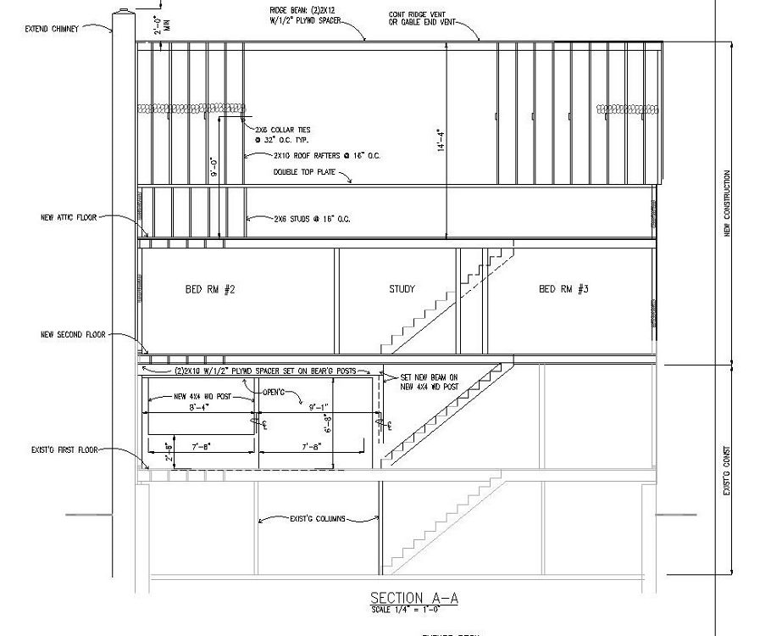
First Floor: I cannot extend the stairwell towards the bathroom side of the house (to the right) because there is not enough room between the door for the basement stairs and the half bath on the first floor (33” now). If I extend the stairwell towards the chimney wall (to the left below), I would have to remove the ceiling plaster on the first floor from the middle load bearing wall to the front of the house (3ft x 13ft) and try to move the doubled up joist over to the next joist away from the stairs without breaking it or damaging the electrical wires that are threaded through it. I’d also have to extend the walls on each side of the stairs, and as stated previously, in the basement I’d have to add two more lally columns to line up with the start of the stairs on the 1st floor.
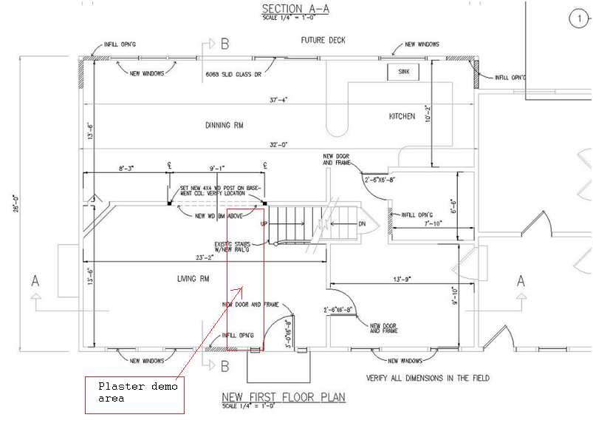
Second Floor: On the second floor I can’t move the stairs towards the bathrooms because of the first floor limitations and also because the ceiling joist direction changes. Except for the 2nd floor ceiling joists over the 2nd floor bathrooms, all floor/ceiling joists run from the front of the house to back. Only above the bathrooms do they change direction as indicated by the red lines below. The long red line is the normal joist direction, and it’s also a critical load bearing LVL beam. The joist direction is changed over the bathrooms because of the large landing at the top of the stair and so the bathroom exhaust ducts can run out the side of the house so they aren’t seen in the backyard.. The LVL beam can’t be moved. On the left side of the stairs, I can’t move to the left easily because there is ductwork for the hvac system that runs to the study from the back of the house, as indicated by the blue box. It would very difficult to move. Also, again the doubled up joists in the ceiling would have to be moved (carefully) and again wiring is now in the way. I would have to tear down the ceilings in the master bedroom and hallway and pray that the doubled up joist did not break when moved..
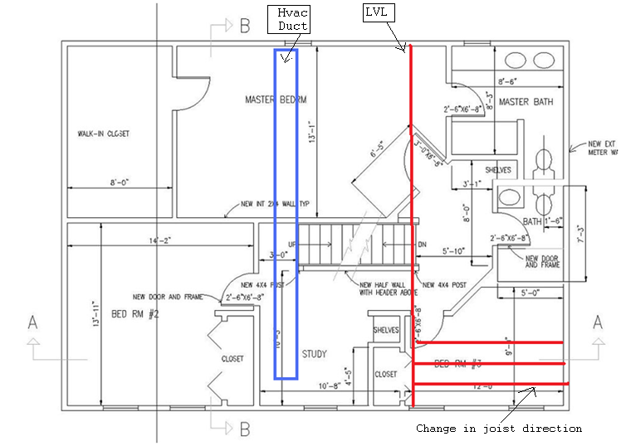

Third floor: If the 2nd floor to attic stairwell is lengthened one foot the left (only option because of LVL on 2nd floor), then the 2x4 wall that surrounds the stairs in the attic would also need adjusting as well. This would be difficult due to the electrical wiring in this wall. I created this drawing by using the 2nd floor plan, and I modified it in Microsoft Paint. It’s not part of the submitted plans to the Building Inspector, but I believe it is accurate enough to show the issue..
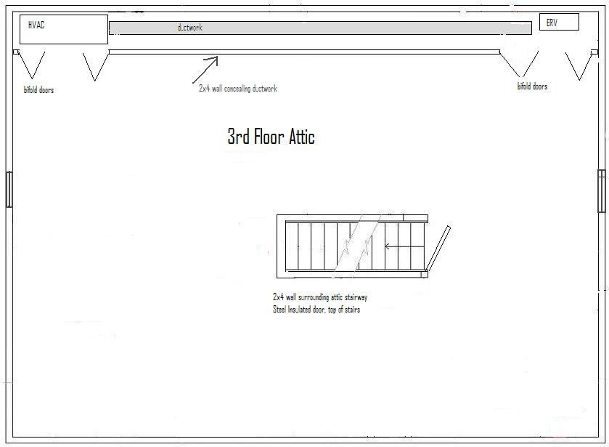

In summary, I hope I have made the case that it would cause a great hardship to fix the stair tread depth issue because I would have to lengthen the stairwell framing, which would essentially mean gutting a good portion of the house again and starting much of the project over.
While, I’m disappointed that I didn’t catch this mistake earlier, I hope that being 81/4” vs 9” won’t be considered unsafe.

Thank you for your time and consideration

Daniel C. Hunneyman

Further Background info about myself and the house project (if it helps)
I’m currently a global system administrator for a large pharmaceutical company, helping to deploy paperless notebook computer systems for Quality Control Laboratories worldwide within my company. I’m not a builder/contractor by training (BS in Chemistry), and I’m not planning on making a living doing this type of work. I do enjoy woodworking and boatbuilding, and I first learned my remodeling skills working with my father as a kid (started when I was around 8 years old). I helped my father remodel a house built in the late 1860’s.
I started my current remodeling project in Shrewsbury because I felt I could build a house more energy efficient than anything I could buy, while saving money doing a lot of the work myself.
I contracted out the roof removal, rough framing, siding, roofing. closed cell foam spraying, plumbing, HVAC & ERV install, and plastering.. I did all the electrical, fiberglass installation, painting, tiling, and finish work.
On a positive note, the house now has superb insulation. When I gutted the ranch, it only had mostly wet 1” rock wool that had sagged in most of the wall cavities (meaning no insulation at all). There was also no insulation in the attic other than a thin 1” layer of vermiculite when I bought the house in 1998 (I did add 1 layer of unfaced R-30 in the attic between the floor joists, but I don’t think it did much). Now the new house has R-27 in the walls and R-56 in the roof ceiling, due to a combination of closed cell foam and fiberglass, and in the attic, an additional layer of 2” foamboard under the roof joists. I use less heating oil now, even though I’ve added 2000 sq ft to the house. Also, because closed cell foam does not absorb water or allow air movement, over time my insulation won’t degrade performance-wise. The only catch with closed cell foam is that it’s expensive ($1/inch per sq ft), and you have to install an ERV ventilator so the house has fresh air and to prevent mold growth. It’s that air tight.
I’ve also had a energy efficient woodstove insert installed in the living room fireplace. Thinking ahead, I’ve pre-installed a $600 fifty ft run of stainless steel flexible pipe designed for a passive solar hot water system. I also ran a separate 2” plastic conduit run from the basement to the attic so that it will be much easier to add a photovoltaic solar system in the future if desired. In my opinion, the house has been vastly improved from what it was, and I hope this variance request will be approved given the overall good I’ve done for the house and the general neighborhood by remodeling it. Hopefully this document shows that I really do care about my house, and that this mistake was unintentional. I really wanted to do it right, and I’m disappointed I didn’t catch this mistake when it could have been much more easily fixed.
There are more photos than you ever want to see on my house project on my website www.hunneyd.net, click on the home remodeling link at top left.

